**Docker Image to Run Test Cases**

**Prerequisites:**

1. **Docker Desktop:**

* Windows 10 Pro, Enterprise, and Education:

<https://docs.docker.com/docker-for-windows/install/>

* For Windows 10 Home:

<https://docs.docker.com/docker-for-windows/install-windows-home/>

1. **Git(if required)**

* GitBash Installation for windows:

<https://git-scm.com/download/win>

**To run the test cases in a Docker Container(testing-server), please follow the steps below:**

**Step - I**

* 1. Unzip the given **‘testing-project-docker’** folder.

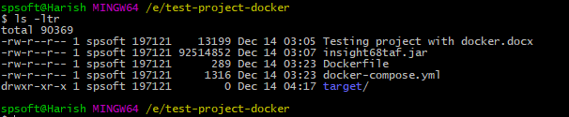

* 1. Go to ‘target/’ folder and edit the ‘remoteURL’ and ‘zapaddress’variables with local ip-address in ‘configuration.properties’file. Refer to the following table:

|  |  |
| --- | --- |
| **Property** | **Value** |
| *androidRemoteURL* | Change this variable with local ip address to connect with appium and android emulator. |
| *remoteURL* | Change this variable with local ip address connect withthe chrome driver url. |
| *zapaddress* | Change this variable with local ip to connet to zap server. |
| *qaURL* | Change this variable to connect with testing server url(subscription application url). |
| *mailReceivedUser* | Change this variable with any email id to receive testing reports after completion of tests. |

**Example(refer to the below image):**

Edit the ‘remoteURL’ variable with your local IP Addressin ‘configurations.properties’ file.

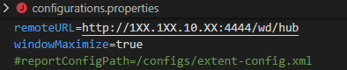

**Step - II**

1. Open **git bash or cmd** prompt terminal and go to **testing-project-docker** folder where *target folder,insight68taf.jar file,*and*docker-compose.yml* exist.
2. Run the below command:

*“docker-compose up -d --build”*.

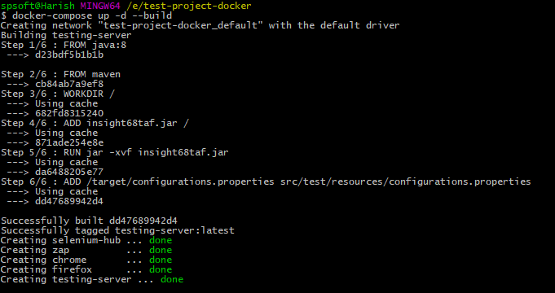

1. After executing the command, DockerContainers will spin up. We can see the status of the containers in “Docker Desktop” UI.

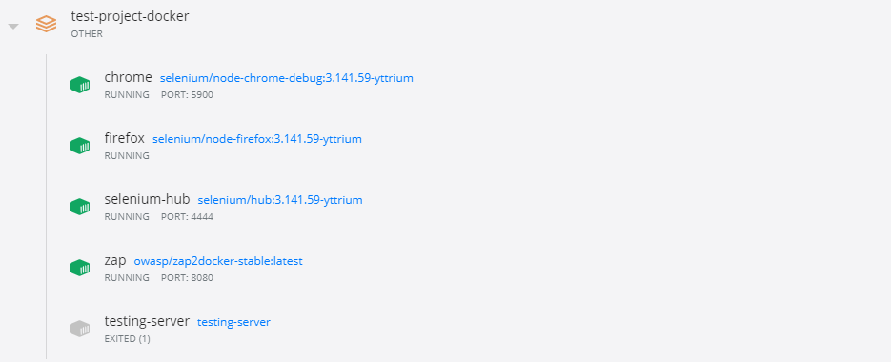

**Step – III**

1. Execute the below command to enter into the ‘testing-server’ container:

“*docker container run -it testing-server bash*”

1. Execute ‘mvn test’ command torun the test cases. (Or) we can run testing directly by executingthe below command:

“*docker run testing-server mvntest*”.

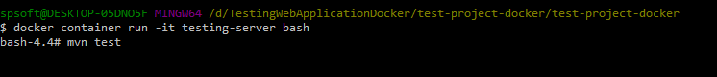

1. Test reports are generated and are sent to the given email-id value in “*mailReceivedUser*” variablein the *configuration.properties* file.



**Note**: Mobile tests are included but to run them, local machine must have appium,

android emulator and they should be running with the given apk file installed in emulator.

Please find steps below to install appium and android-emulator.